**MNIST DATASET**

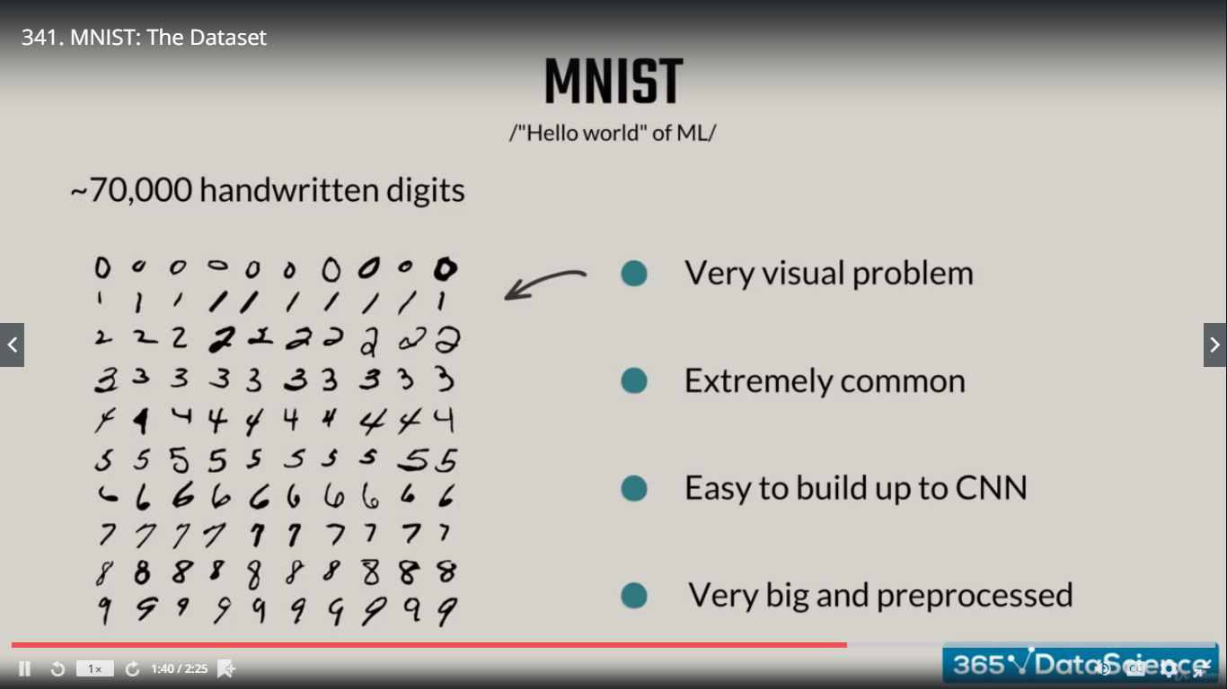

**Credits :-** Yan LeuCun, Corinna Cortes, Christopher Burges

|  |  |
| --- | --- |
| More about MNIST | More about Yan LeCun |
| yann.lecun.com | Founding father of CNNs  Head of AI Research at facebook |

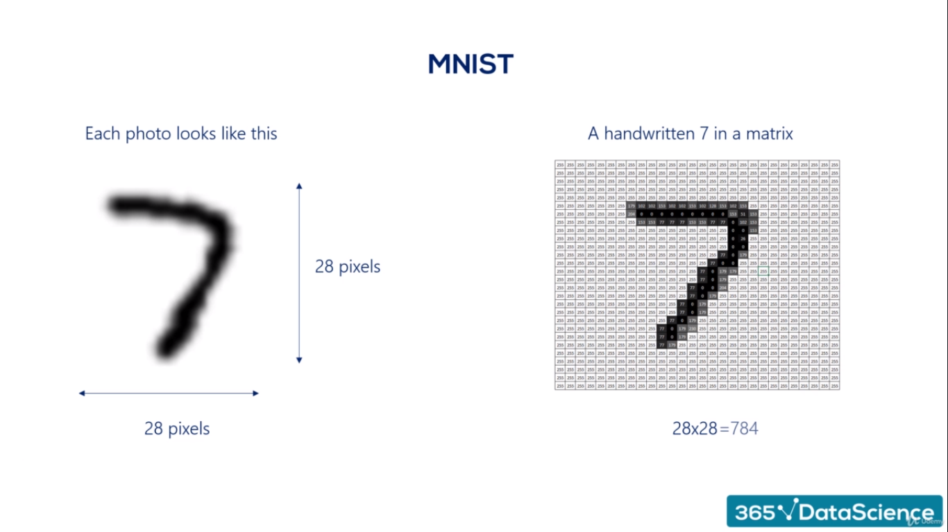

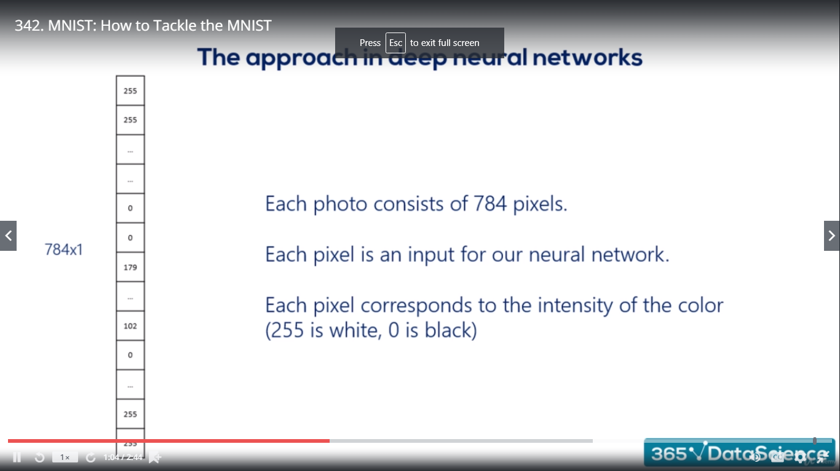

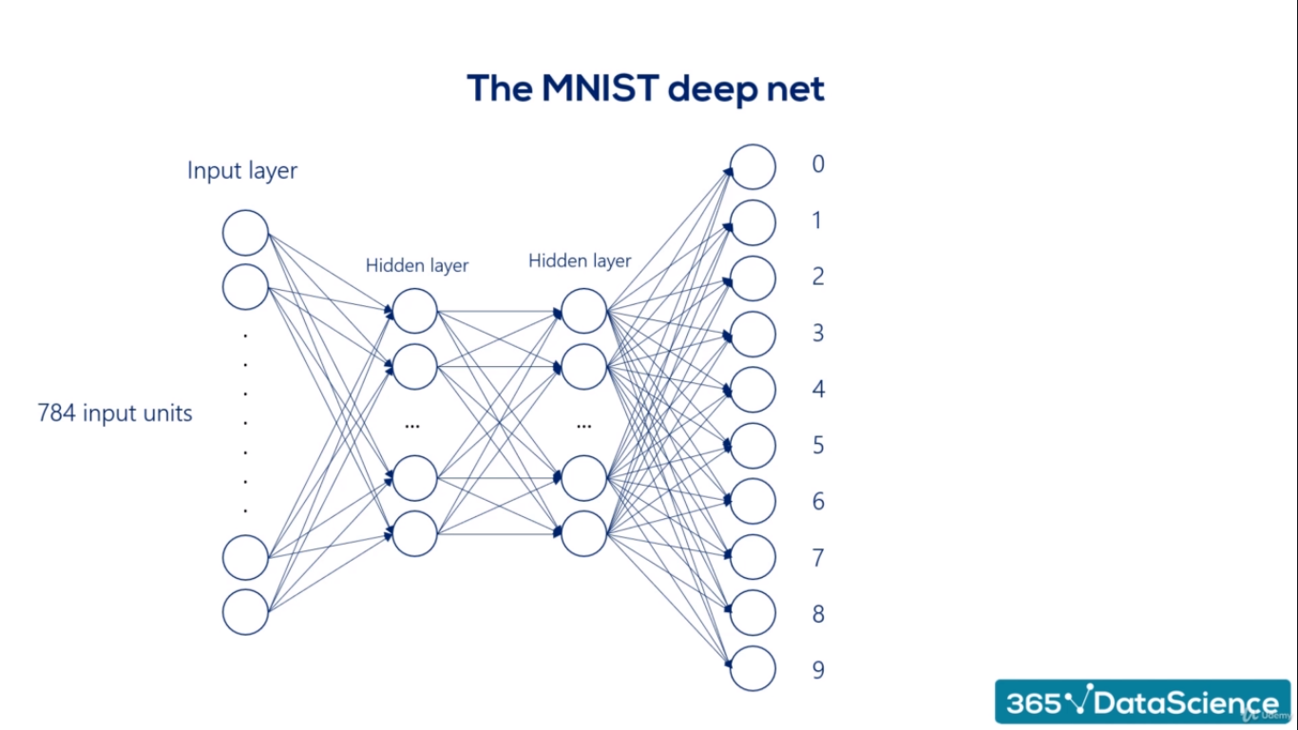

**THE MNIST Action Plan**

1. Prepare our data and preprocess it. Create training, validation and test datasets.
2. Outline and model and choose the activation function
3. Set the appropriate advanced optimizers and loss function
4. Make it learn
5. Test the accuracy of the function.



**Deep Learning**

**Business Case Example**

**THE BUSINESS CASE ACTION PLAN**

1. Preprocess the Data 🡪 We will show you a coupe of common techniques
   1. Balance the dataset 🡪 The dataset should be equally distributed in the categories, not polarized
   2. Divide the dataset in training, validation and test 🡪 prevent overfitting
   3. Save the data in a tensor friendly format 🡪 good old.npz
2. Create the machine learning algorithm 🡪 same structure, different model





**Deep Learning - Conclusion**

**CNNs (Convolutional Neural Network)**

**RNNs (Recurrent Neural Network)**

The deep learning involved in WaveNet: [https://deepmind.com/blog/high-fidelity-speech-synthesis-wavenet/](https://deepmind.com/blog/wavenet-launches-google-assistant/)

Alternatively, you can just listen and compare the speech synthesis (listen to the results) here: <https://deepmind.com/blog/wavenet-launches-google-assistant/>

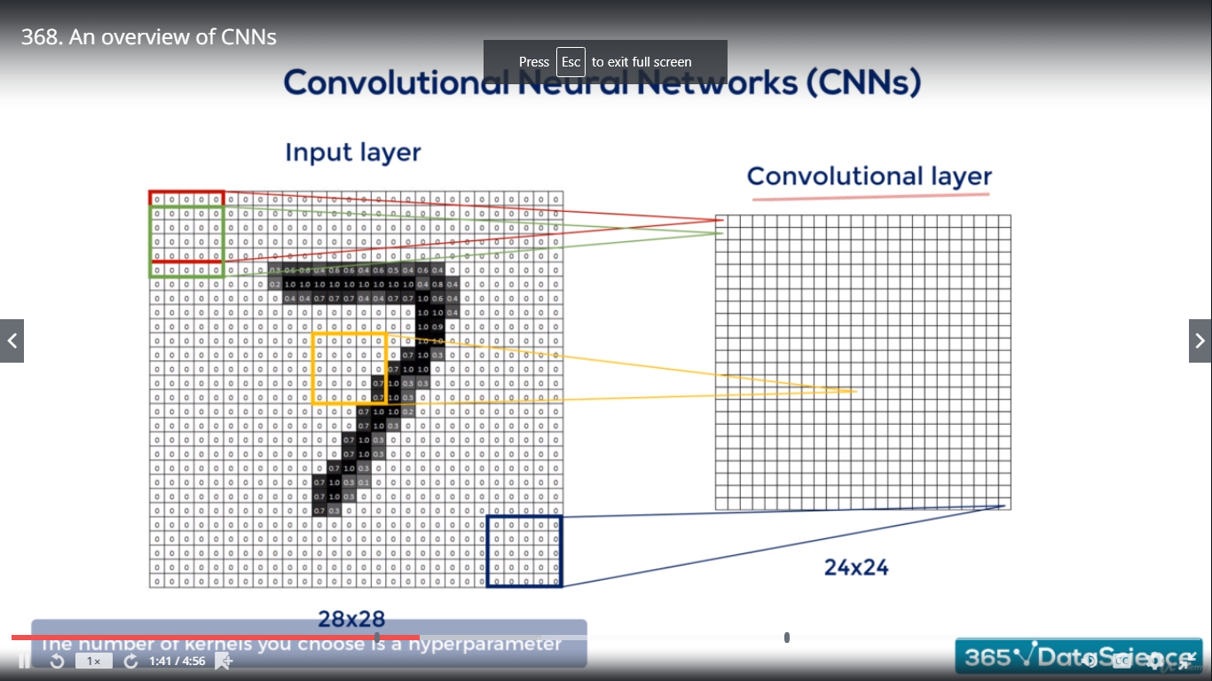

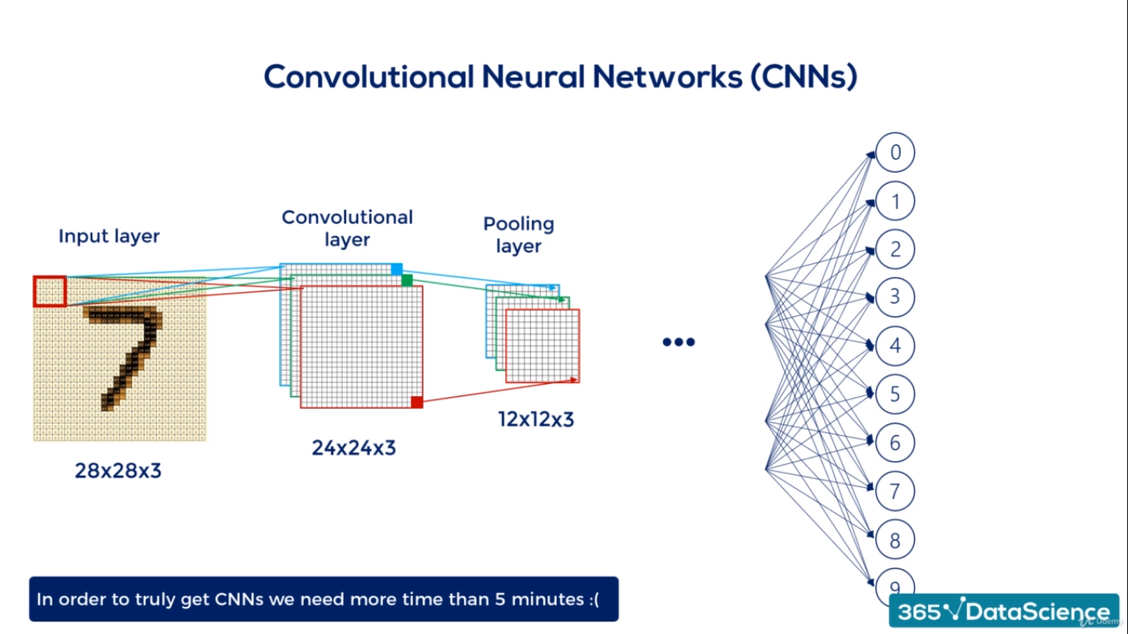

In deep learning, a convolutional neural network (CNN, or ConvNet) is a class of deep neural networks, most commonly applied to analyzing visual imagery. They are also known as shift invariant or space invariant artificial neural networks (SIANN), based on their shared-weights architecture and translation invariance characteristics.[1][2] They have applications in image and video recognition, recommender systems,[3] image classification, medical image analysis, and natural language processing.

**CNNs - Image Recognition**

* Spatial proximities are preserved
* A detail is looked for everywhere in a photo (eye)

**Used by:** Google, Apple, amazon.com, Microsoft, Tesla, out of reach of common people

**RNN (Recurrent Neural Network)- Sequential Data**

A recurrent neural network (RNN) is a class of artificial neural networks where connections between nodes form a directed graph along a temporal sequence. This allows it to exhibit temporal dynamic behavior. Unlike feedforward neural networks, RNNs can use their internal state (memory) to process sequences of inputs. This makes them applicable to tasks such as unsegmented, connected handwriting recognition[1] or speech recognition.[2][3]

* Trading
* Music
* NLP (depend on what you’ve said before)

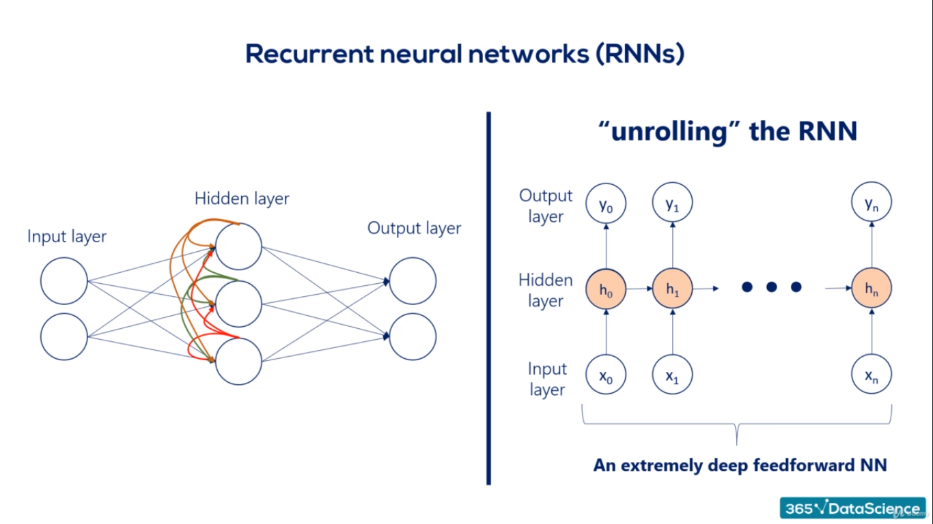

**We must learn weights as well.**

**More Complex Neural Networks (CNNs + RNNs)**

**An Overview of Non-Neural Network Approaches:**

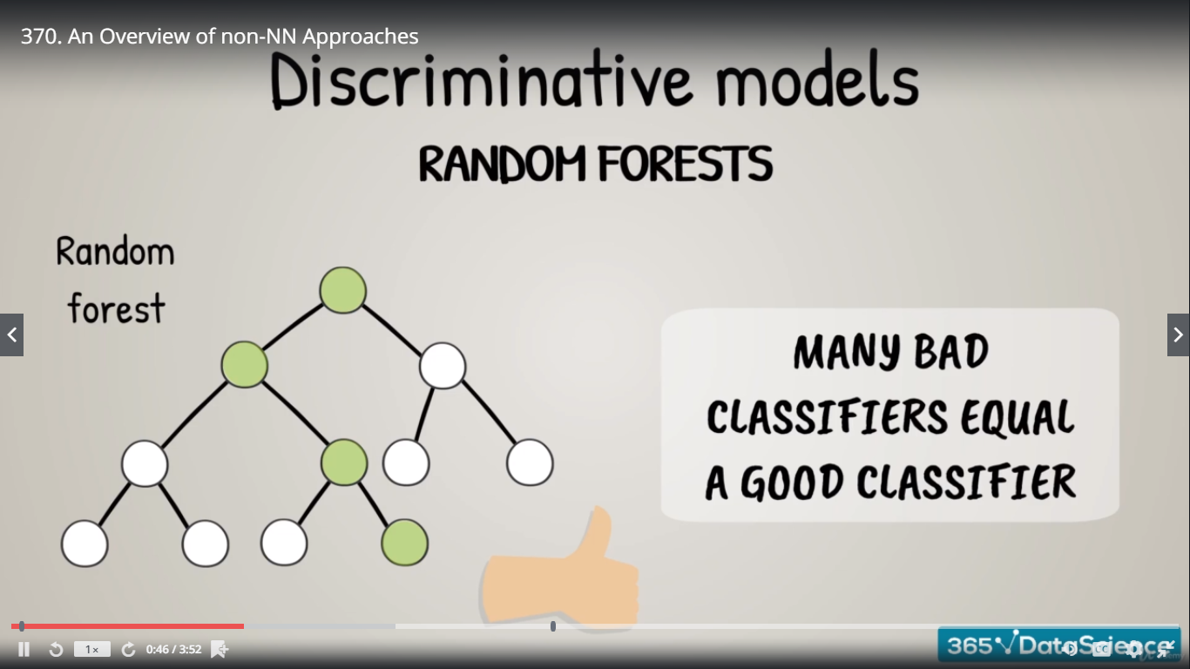

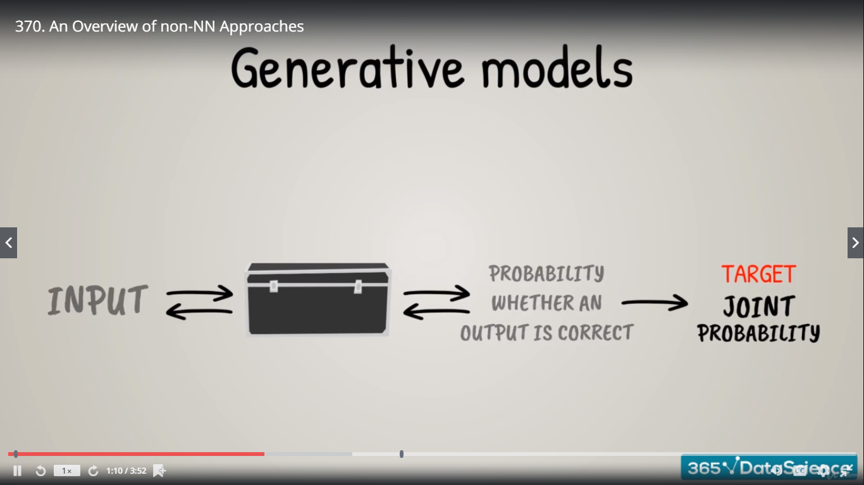

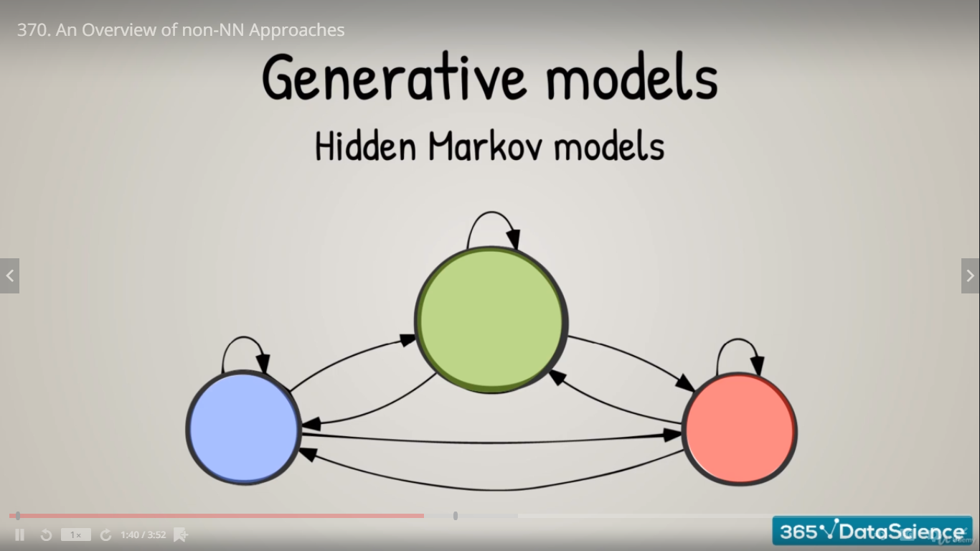

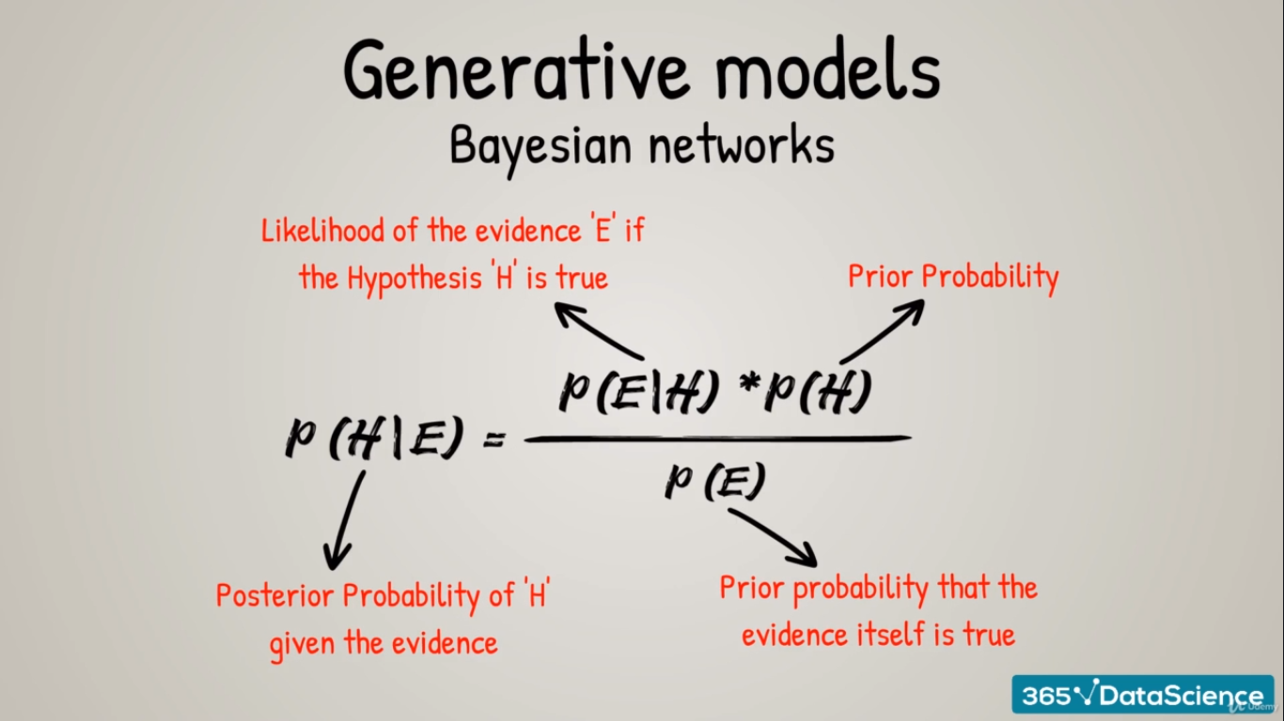

**Each problem, no matter if an image, a business problem or a Shakespeare sonnet, tells a story. With the right tools you can reveal it and take advantage of it.**